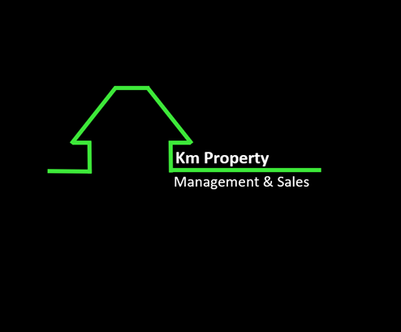

Repairs and Maintenance Request Form
All maintenance requests MUST be received in writing.

Address: 86 Murilla Street, Miles QLD 4415
Email: reception@kmpm.com.au
Phone: 46272710
DETAILS
Date: ____ /____ /
Property address: Tenant/s: _______________________________________________________________________________________________
MAINTENANCE
Tenants contact no:

Plumbing Electrical General Repairs Other, specify: Model of Appliance if applicable:
COMMENTS
ACCESS TO PROPERTY

Please choose one of the following options regarding the tradespersons access to carry out maintenance at the property

The tradesperson can collect keys from Explore Property and attend the property without me being present I wish to be present when the tradesperson attends the property
OFFICE USE ONLY

Date received: / /
Received by: Landlord name:
URGENT NOT URGENT

Tradesperson Organised: Work Order Sent:

